JAVA PROGRAMMING

QUESTION

Submitted by

Tamilvanan B.

2018503566.

MO Batch.

09-24-2020.

1. Write a java programming that includes the following features

a. Class named BankTransaction with members customerId, transactionId and transactionAmount. Add a parameterized constructor to initialize the members.

b. Create three objects named obj1, obj2 and obj3.

c. Compare the objects using equals method. Display its hashcodes.

d. Try to override the equal() method by considering the equality in state along with object references. Display its hashcodes and classname.

e. Assign obj3 to obj2. Compare and display hashcodes.

Program

import java.util.Scanner;

import java.io.*;

class BankTransaction{

public int customerId;

public int transactionId;

public int transcationAmount;

BankTransaction(int a, int b, int c){

this.customerId = a;

this.transactionId = b;

this.transcationAmount = c;

}

@Override

public boolean equals(Object obj){

System.out.println("Inside the overridden equals() method, Class name is " + obj.getClass() + " and hashCode is " + obj.hashCode() + "\n");

if(this == obj){

return true;

}

if (obj == null || obj.getClass() != this.getClass()){

return false;

}

BankTransaction bank_obj = (BankTransaction) obj;

return (bank_obj.customerId == this.customerId && bank_obj.transactionId == this.transactionId && bank_obj.transcationAmount == this.transcationAmount);

}

}

public class Main{

public static void main(String... args){

Scanner sc = new Scanner(System.in);

BankTransaction obj1 = new BankTransaction(1,32,1000);

BankTransaction obj2 = new BankTransaction(3,34,2000);

BankTransaction obj3 = obj2;

System.out.println("\nComparing object 1 and 2\n");

if(obj1.equals(obj2)) {

System.out.println("All the objects are equal");//Both objects pointing same address

}

else{

System.out.println("All the objects are not equal");

}

System.out.println("\nComparing object 2 and 3\n");

if(obj2.equals(obj3)) {

System.out.println("All the objects are equal");//Both objects pointing different address

}

else{

System.out.println("All the objects are not equal");

}

System.out.println("\nThe HashCodes for Obj1 is " + obj1.hashCode() + ", Obj2 is " + obj2.hashCode() + " and Obj3: " + obj3.hashCode());

}

}

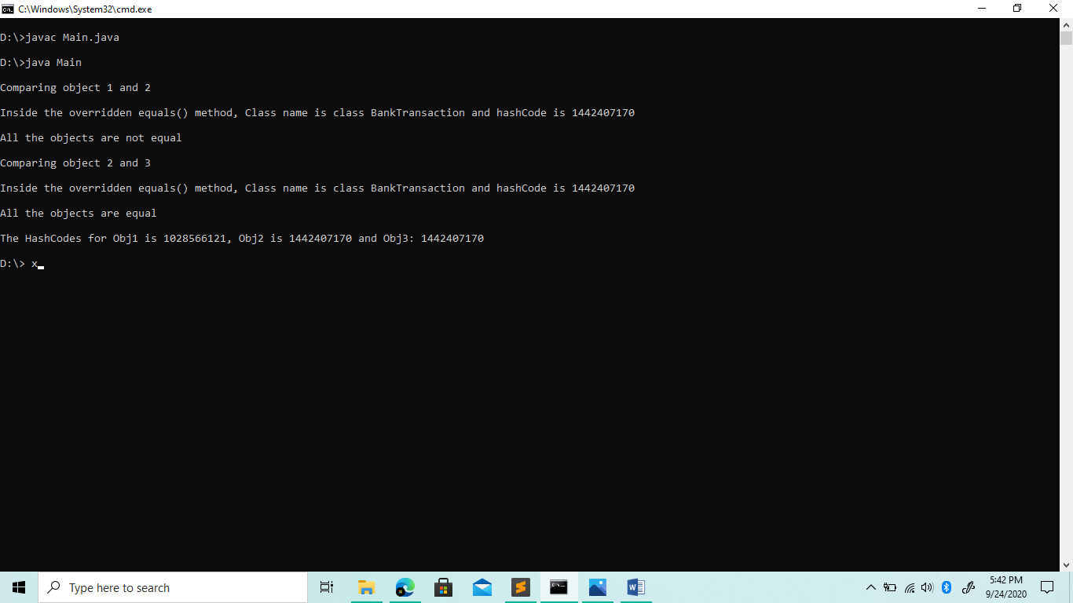Output